Flow Tracking System
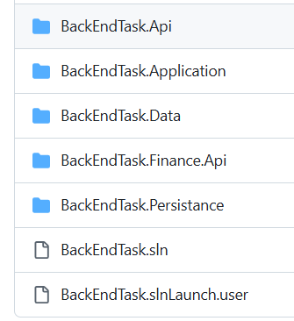
- It is CQRs Architect

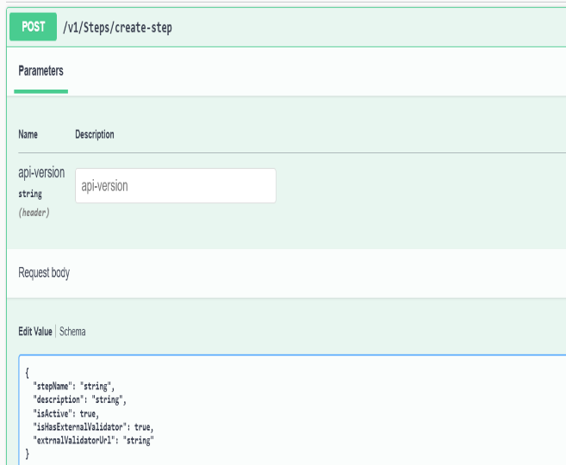
- Setup Steps
- Use api v1/Steps/create-step To Create Steps to create steps as codes

  - Use api v1/Workflow/create-workflow create work flow for approvment


- Use api v1/process/start to start work flow

- Use api v1/process/execute to Execute Step In Flow
- Use api v1/process/process

